Business Requirement:
Develop an Uploader by using which you can upload Master data on any Z or Y table (Custom Table).
---------------------------------------------------------------------------------
Program Name : ZR_MASTER_DATA_UPLOAD
Description: Uploading data into custom( Z ) table from Excel
- ---------------------------------------------------------------------------------------------------------
- *&---------------------------------------------------------------------*
*& Report ZR_MASTER_DATA_UPLOAD
*&---------------------------------------------------------------------*
*&
*&---------------------------------------------------------------------*
REPORT zr_master_data_upload.
*TABLES : zmm_vend_grp.
*DATA:it_final TYPE STANDARD TABLE OF zmm_vend_grp,
* wa_final TYPE LINE OF it_final.
DATA:lt_excel TYPE TABLE OF alsmex_tabline,
lt_dref TYPE REF TO data,
ls_dref TYPE REF TO data,
lv_col TYPE i,
lo_alv TYPE REF TO cl_salv_table,
lt_table_filds TYPE TABLE OF dfies.
*** --- Field Symbols
FIELD-SYMBOLS : <fs_table> TYPE any .
FIELD-SYMBOLS : <ft_table> TYPE STANDARD TABLE.
FIELD-SYMBOLS : <dyn_field> .
*** --- Selection screen designing
SELECTION-SCREEN BEGIN OF BLOCK b1 WITH FRAME TITLE TEXT-001.
PARAMETERS:p_file TYPE rlgrap-filename OBLIGATORY,
p_table TYPE dd02l-tabname OBLIGATORY,
p_test AS CHECKBOX DEFAULT abap_true.
SELECTION-SCREEN END OF BLOCK b1.
AT SELECTION-SCREEN ON p_table.
IF p_table+0(1) NE 'Z'.
MESSAGE 'You cannot update standard table.' TYPE 'E'.
ENDIF.
*** --- value request for p_file
AT SELECTION-SCREEN ON VALUE-REQUEST FOR p_file.
CALL FUNCTION 'F4_FILENAME'
IMPORTING
file_name = p_file.
*** --- START-OF-SELECTION
START-OF-SELECTION.
*create OBJECT lr_descr.
*** --- Assigning fields symbols for Tables
CREATE DATA lt_dref TYPE TABLE OF (p_table).
CREATE DATA ls_dref TYPE (p_table).
*** --- Assign field symbol with table type of DDIC
ASSIGN lt_dref->* TO <ft_table>.
*** --- Assign field symbol with Structure type of DDIC
ASSIGN ls_dref->* TO <fs_table>.
*** --- Call the Function module ALSM_EXCEL_TO_INTERNAL_TABLE
CALL FUNCTION 'ALSM_EXCEL_TO_INTERNAL_TABLE'
EXPORTING
filename = p_file
i_begin_col = 1
i_begin_row = 1
i_end_col = 99
i_end_row = 999999
TABLES
intern = lt_excel
EXCEPTIONS
inconsistent_parameters = 1
upload_ole = 2
OTHERS = 3.
IF sy-subrc EQ 0.
*** --- Sort
SORT lt_excel BY row.
LOOP AT lt_excel INTO DATA(ls_excel).
*** --- Adding count to skip the mapping for MANDT field
* lv_col = ls_excel-col + 1.
lv_col = ls_excel-col .
ASSIGN COMPONENT lv_col OF STRUCTURE <fs_table> TO <dyn_field>.
IF sy-subrc = 0.
***-- Compare Excel sheet column data and Dynamic table fields
IF ls_excel-row = 1.
CALL FUNCTION 'DDIF_FIELDINFO_GET'
EXPORTING
tabname = p_table
TABLES
dfies_tab = lt_table_filds
EXCEPTIONS
not_found = 1
internal_error = 2
OTHERS = 3.
READ TABLE lt_table_filds INTO DATA(ls_table_fields) INDEX lv_col.
IF sy-subrc = 0.
IF ls_table_fields-fieldname NE ls_excel-value.
WRITE: 'Excel sheet data and Dynamic table fields are not matching'.
EXIT.
ENDIF.
ENDIF.
ELSE.
IF ls_excel-value+2(1) = '.' AND ls_excel-value+5(1) = '.' OR
ls_excel-value+2(1) = '/' AND ls_excel-value+5(1) = '/'.
CONCATENATE ls_excel-value+6(4) ls_excel-value+3(2) ls_excel-value+0(2) INTO <dyn_field>.
ELSE.
<dyn_field> = ls_excel-value.
ENDIF.
ENDIF.
ENDIF.
IF ls_excel-row GT 1.
AT END OF row.
APPEND <fs_table> TO <ft_table>.
CLEAR <fs_table>.
ENDAT.
ENDIF.
ENDLOOP.
IF <ft_table> IS NOT INITIAL.
IF p_test IS INITIAL.
*** --- Modify
MODIFY (p_table) FROM TABLE <ft_table>.
IF sy-subrc EQ 0.
COMMIT WORK.
DATA(lv_lines) = lines( <ft_table> ).
WRITE: TEXT-002,lv_lines.
ELSE.
ROLLBACK WORK.
MESSAGE TEXT-003 TYPE 'E' DISPLAY LIKE 'I'.
ENDIF.
ELSE.
*** --- Factory Method
cl_salv_table=>factory(
IMPORTING
r_salv_table = lo_alv " Basis Class Simple ALV Tables
CHANGING
t_table = <ft_table>
).
*** --- Display
lo_alv->display( ).
ENDIF.
ENDIF.
ENDIF.
Testing Screen
Note :Here we have to take same to same technical name of Field of the database in Uploader with Sequence,
TABLE NAME : Z9078TEST
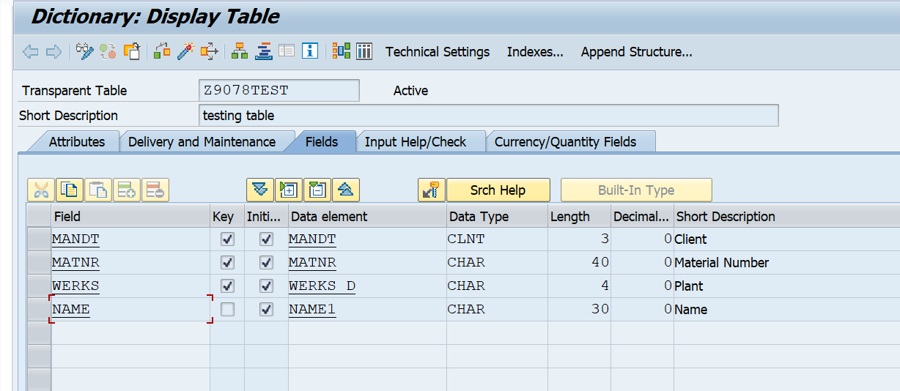
Excel
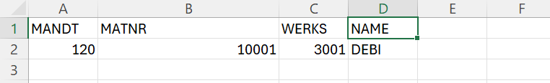
Case 1: If Test check box is Checked.
Input SCREEN
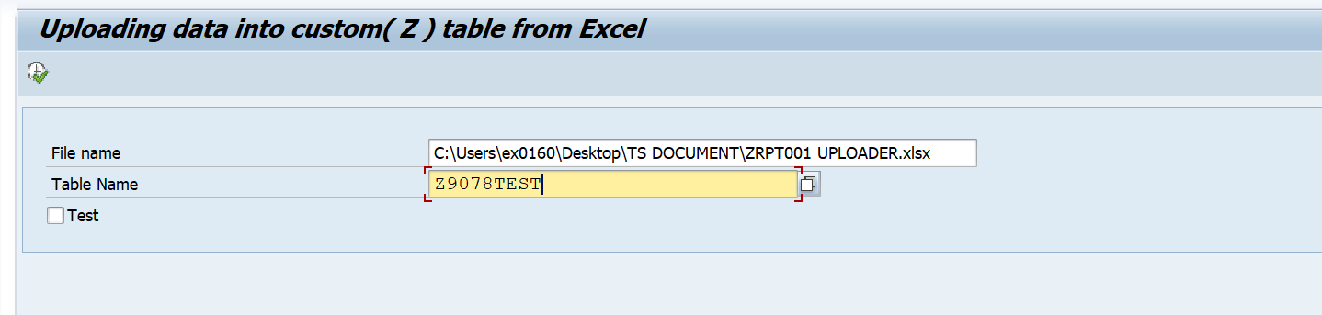
Output screen.
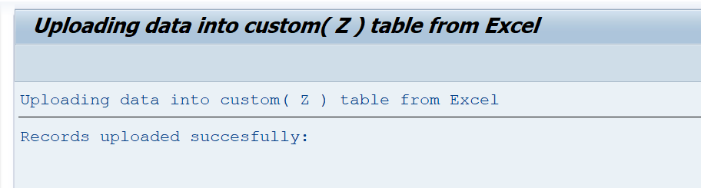
Record in Database.
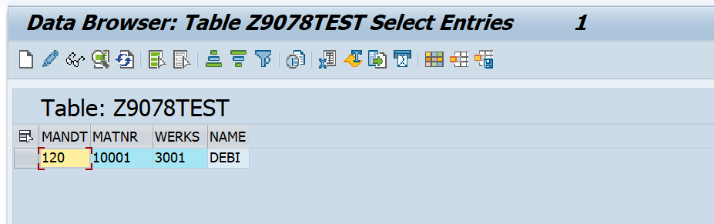

Case 2: If Test check box is not Checked.
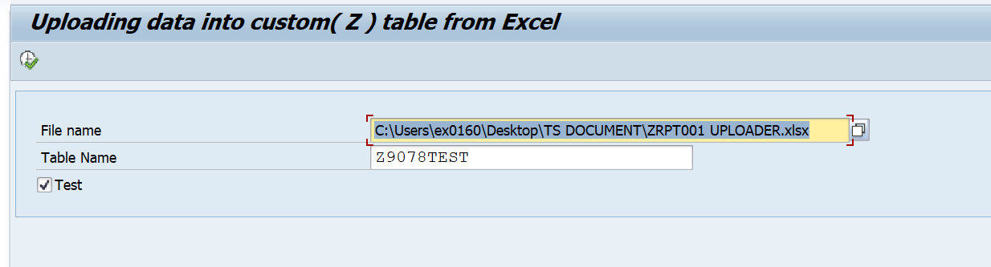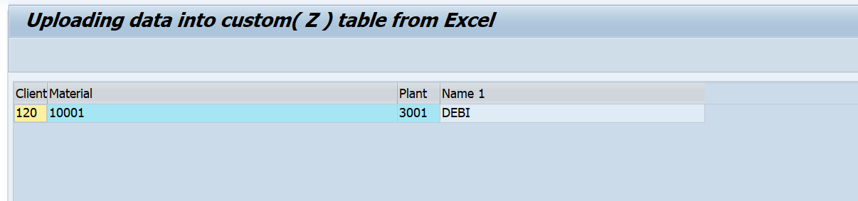
Note: Test Check box provided to check before upload and it’s recommended

